**AIDA**

*---Created by Sirri Ayongwa----*

**TABLE OF CONTENTS**

1. INTRODUCTION---------------------------------------------
2. PROBLEM STATEMENT-----------------------------------------
3. PROBLEM SOLUTION----------------------------------------
4. FEATURES AND BENEFITS--------------------------------------
5. TECHNOLOGY USED--------------------------------------------
6. FLOWCHART-----------------------------------------------
7. CONCLUSION---------------------------------------------------

### INTRODUCTION

We all observe that when individuals fall ill or are injured, they are taken to hospitals or doctors for treatment. But it takes time to reach them, during which if some initial care is taken, it helps treatment of such individuals and in many cases saves their lives. We also observe that some of the minor illnesses or injuries are cured by taking some initial care. However, this care cannot be taken unless we are aware and trained in first-aid.

### PROBLEM STATEMENT

There are many medical emergencies where time is of essence. A sick or injured person may not be able to hang on long enough, until professionals arrive.

Sometimes when someone is injured, what they do to treat that injury can increase or decrease the likelihood of infection without a proper knowledge of what to do at that particular time, to ease the pain.

Not giving someone first aid can lead to death, but even if they live, they could deal with longer recovery time.

### PROBLEM SOLUTION

With the problems listed, I created a first aid program to educate, and enlighten non-expert persons and expert first aiders to have adequate knowledge of what to do when they are faced with some injuries.

Our program is easy to understand even by non-users at a glance, it provides some quick test to test oneself in case one meets such incident, he/she could apply the necessary steps provided, to ease an injury.

### FEATURES AND BENEFITS

* Modifies score – adds a point to the previous one when a question is correctly answered.
* Score – displays the highest score, shown after you return to the main menu when your game ends.
* Help – a help menu with an explanation of the game and its rules/guides which makes the game easily accessible by the user.
* Tips – displays a suggestion that will aid you answer a question correctly, after a wrong attempt

### TECHNOLOGY USED

* AIDA GAME is programmed with C programming using Code blocks as the IDE.
* The flow chart was created using Diagrams.net.

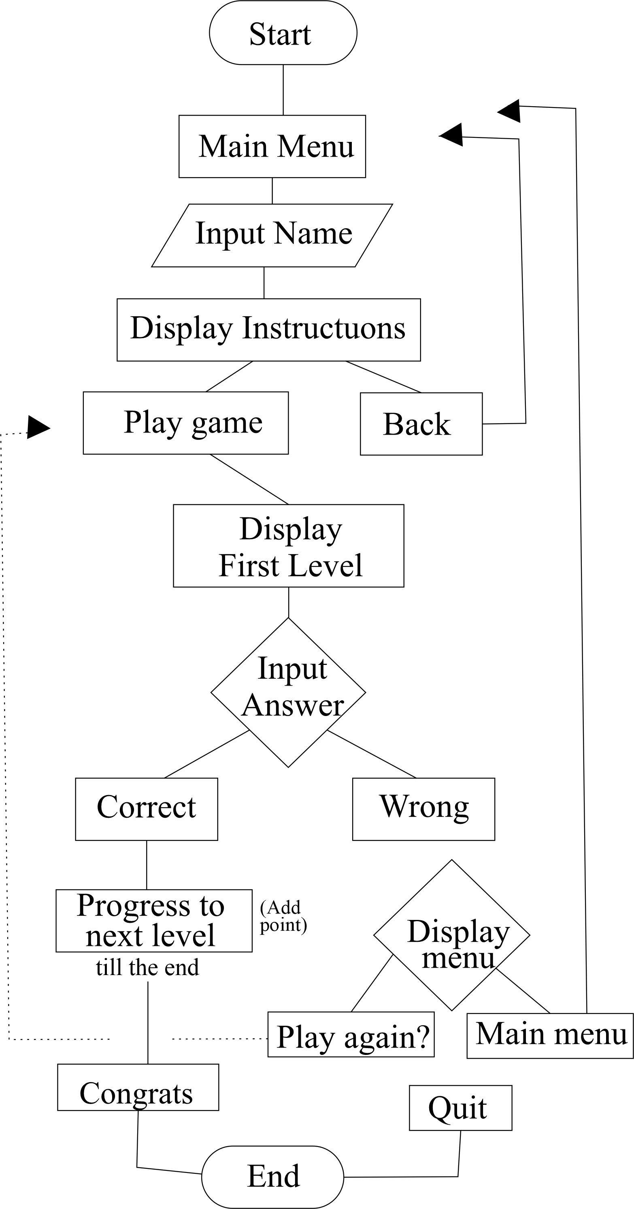

### CONCLUSION

The project AIDA GAME was completed successfully. The program has been developed with much care, free of errors and at the same time it is efficient and less time consuming. The purpose of this project was to develop that will grow the knowledge of First Aid in our today’s society which can in turn be a good measure to prevent minor injuries and manage minor accidents before being attended to by a health specialist. This project helped me in gaining valuable information and practical knowledge of what to do when we are faced with some of the minor occurrences. I hope you have a good time exploring AIDA GAME.